| Experiment No. 9 |
| --- |
| Implement Character Generation method : Bit Map method |
| Name: KRITHIK DEVENDRA PANDEY |
| Roll Number: 35 |
| Date of Performance: |
| Date of Submission: |

**Experiment No. 9**

**Aim:**  To implement Character Generation: Bit Map Method

**Objective:**

Identify the different Methods for Character Generation and generate the character using Stroke

**Theory:**

**Bit map method –**

Bitmap method is a called dot-matrix method as the name suggests this method use array of bits for generating a character. These dots are the points for array whose size is fixed.

· In bit matrix method when the dots are stored in the form of array the value 1 in array represent the characters i.e. where the dots appear we represent that position with numerical value 1 and the value where dots are not present is represented by 0 in array.

· It is also called dot matrix because in this method characters are represented by an array of dots in the matrix form. It is a two-dimensional array having columns and rows.

A 5x7 array is commonly used to represent characters. However, 7x9 and 9x13 arrays are also used. Higher resolution devices such as inkjet printer or laser printer may use character arrays that are over 100x100.

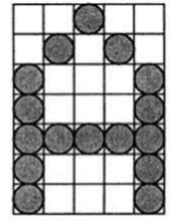

**Starburst method –**

In this method a fix pattern of line segments is used to generate characters. Out of these 24-line segments, segments required to display for particular character are highlighted. This method of character generation is called starburst method because of its characteristic appearance. The starburst patterns for characters A and M. the patterns for particular characters are stored in the form of 24 bit code, each bit representing one line segment. The bit is set to one to highlight the line segment; otherwise, it is set to zero. For example, 24-bit code for Character A is 0011 0000 0011 1100 1110 0001 and for character M is 0000 0011 0000 1100 1111 0011.

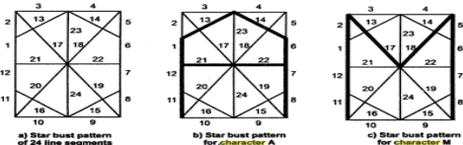

**Program:**

#include <stdio.h>

#include <conio.h>

#include <graphics.h>

int main()

{

int i,j,k,x,y;

int gd=DETECT,gm;//DETECT is macro defined in graphics.h

/* ch1 ch2 ch3 ch4 are character arrays that display alphabets */

int ch1[][10]={ {1,1,1,1,1,1,1,1,1,1},

{1,1,1,1,1,1,1,1,1,1},

{0,0,0,0,1,1,0,0,0,0},

{0,0,0,0,1,1,0,0,0,0},

{0,0,0,0,1,1,0,0,0,0},

{0,0,0,0,1,1,0,0,0,0},

{0,0,0,0,1,1,0,0,0,0},

{0,1,1,0,1,1,0,0,0,0},

{0,1,1,0,1,1,0,0,0,0},

{0,0,1,1,1,0,0,0,0,0}};

int ch2[][10]={ {0,0,0,1,1,1,1,0,0,0},

{0,0,1,1,1,1,1,1,0,0},

{1,1,0,0,0,0,0,0,1,1},

{1,1,0,0,0,0,0,0,1,1},

{1,1,0,0,0,0,0,0,1,1},

{1,1,0,0,0,0,0,0,1,1},

{1,1,0,0,0,0,0,0,1,1},

{1,1,0,0,0,0,0,0,1,1},

{0,0,1,1,1,1,1,1,0,0},

{0,0,0,1,1,1,1,0,0,0}};

int ch3[][10]={ {1,1,0,0,0,0,0,0,1,1},

{1,1,0,0,0,0,0,0,1,1},

{1,1,0,0,0,0,0,0,1,1},

{1,1,0,0,0,0,0,0,1,1},

{1,1,1,1,1,1,1,1,1,1},

{1,1,1,1,1,1,1,1,1,1},

{1,1,0,0,0,0,0,0,1,1},

{1,1,0,0,0,0,0,0,1,1},

{1,1,0,0,0,0,0,0,1,1},

{1,1,0,0,0,0,0,0,1,1}};

int ch4[][10]={ {1,1,0,0,0,0,0,0,1,1},

{1,1,1,1,0,0,0,0,1,1},

{1,1,0,1,1,0,0,0,1,1},

{1,1,0,1,1,0,0,0,1,1},

{1,1,0,0,1,1,0,0,1,1},

{1,1,0,0,1,1,0,0,1,1},

{1,1,0,0,0,1,1,0,1,1},

{1,1,0,0,0,1,1,0,1,1},

{1,1,0,0,0,0,1,1,1,1},

{1,1,0,0,0,0,0,0,1,1}};

initgraph(&gd,&gm," ");//initialize graphic mode

setbkcolor(LIGHTGRAY);//set color of background to darkgray

for(k=0;k<4;k++)

{

for(i=0;i<10;i++)

{

for(j=0;j<10;j++)

{

if(k==0)

{

if(ch1[i][j]==1)

putpixel(j+250,i+230,RED);

}

if(k==1)

{

if(ch2[i][j]==1)

putpixel(j+300,i+230,RED);

}

if(k==2)

{

if(ch3[i][j]==1)

putpixel(j+350,i+230,RED);

}

if(k==3)

{

if(ch4[i][j]==1)

putpixel(j+400,i+230,RED);

}

}

delay(200);

}

}

getch();

closegraph();

}

**Output -**

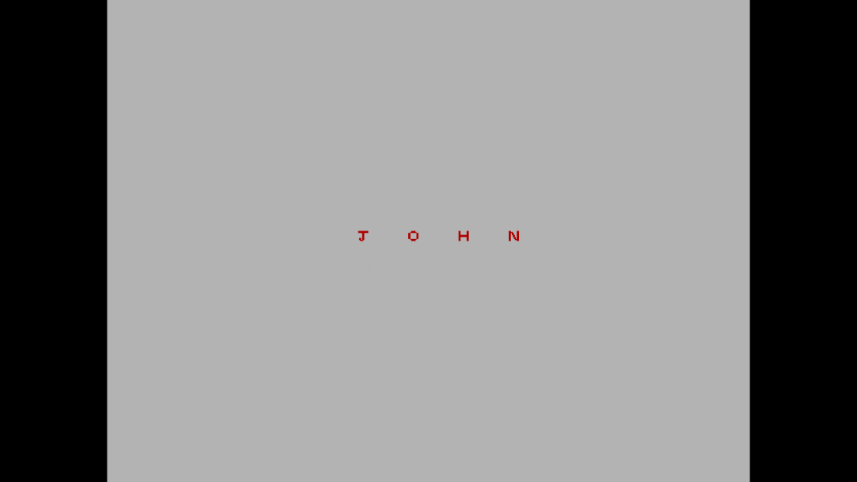

**Conclusion:**  Comment on

1. different methods- Bitmaps are digital images composed of pixels. Monochrome bitmaps use 1 bit for binary colors like black and white. Grayscale bitmaps employ multiple bits for various gray shades, while color bitmaps use more bits or bytes for a wide color spectrum. Bitmaps are a form of raster graphics with fixed resolutions, making them detailed but challenging to scale without pixelation. They can be compressed losslessly (no quality loss) or lossily (with some quality loss) and are editable pixel by pixel using image software
2. advantage of stroke method- One of the notable advantages of this approach is that it allows for precise control over character design. By manipulating the pixel grid, characters can be customized in terms of shape, size, and style. Each character is represented as a set of 1s (on pixels) and 0s (off pixels), making it easy to create unique character designs.
3. one limitation- While the stroke method provides fine-grained control over character design, it is primarily suitable for displaying characters in a pixelated or bitmapped style. The limitation of this method is that it may not scale well to produce characters with smooth curves or fonts with anti-aliased edges. It is best suited for a retro or pixel art aesthetic but may not be ideal for modern, high-resolution, or anti-aliased text rendering, where more advanced text rendering techniques are preferred.